GIT Tutorial For Beginners
(Tutorial by Corey Schafer)

There are 2 types of Version Control System (VCS), Central and Distributed, which will be quickly explained next:

Central VCS is located in one place, people can check out and make their changes, but it’s problematic if you can’t get access to it (server offline/no network), there might no have backups if something goes wrong (corrupted files). Meanwhile in a Distributed VCS every user has a local repository so if you have not internet access you still can view every single change it’s been made, it’s like if every developer has an entire backup of the repository.

Quick How To: Install GIT (git-scm.com), make first time setup such as version validation (should be the newest, git --version), user and email configuration: git config --global user.name "YOUR_NAME", git config --global user.email "YOUR_EMAIL", check those two values with git config –list. Need help? Try this commands: git help <verb>, git <verb> --help (git help config).
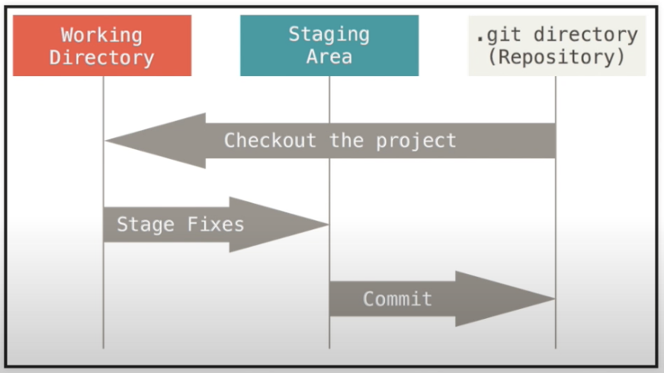

Image above shows us GIT states: working directory, staging area, and .git directory (remote repository).

Before making a commit you must verify if repository has changes, you do not want changes to be lost.

Brief overview of git commands:

Git clone: means downloading a copy of the repository files to your local computer.
Git checkout: best practice to create different branches for different features instead of working on the master branch directly. Can be merged to master branch.
Git pull: recent changes will be pulled to your local repository.
Git add and commit: this commands are almost always used together. Git add goes before Git commit. You can’t save a thing if you don’t capture it first.
Git stash and merge: Stash will stash whatever edit you have made to the branch but do not want to commit. Merge will merge the development branch to your master branch and vice versa.
Git push: sends your local repository to the remote repository for others to access.
Eduardo Alberto Reyes Anaya, 11/23/21

